UNITED STATES

SECURITIES AND EXCHANGE COMMISSION

Washington, D.C. 20549

_______________________

FORM 8-K

_______________________

CURRENT REPORT

PURSUANT TO SECTION 13 OR 15(d)

OF THE SECURITIES EXCHANGE ACT OF 1934

Date of Report (Date of earliest event reported): May 11, 2026

_______________________

SCILEX HOLDING COMPANY

(Exact name of registrant as specified in its charter)

_______________________

Delaware | 001-39852 | 92-1062542
(State or other jurisdiction | (Commission | (IRS Employer
of incorporation) | File Number) | Identification No.)
 | 960 San Antonio Road, Palo Alto, California, 94303
 | (Address of principal executive offices, including zip code)
 | (650) 516-4310
 | Registrant’s telephone number, including area code
 | N/A
 | (Former Name or Former Address, if Changed Since Last Report)
 | _______________________

Check the appropriate box below if the Form 8-K filing is intended to simultaneously satisfy the filing obligation of the registrant under any of the following provisions:

- Written communications pursuant to Rule 425 under the Securities Act (17 CFR 230.425)

- Soliciting material pursuant to Rule 14a-12 under the Exchange Act (17 CFR 240.14a-12)

- Pre-commencement communications pursuant to Rule 14d-2(b) under the Exchange Act (17 CFR 240.14d-2(b))

- Pre-commencement communications pursuant to Rule 13e-4(c) under the Exchange Act (17 CFR 240.13e-4(c)) Securities registered pursuant to Section 12(b) of the Exchange Act:

 | (Title of each class) | (Trading Symbol) |  | (Name of exchange on which registered)
 | Common Stock, par value $0.0001 per share |  | SCLX |  | The Nasdaq Stock Market LLC
Warrants to purchase one share of common |  | SCLXW |  | The Nasdaq Stock Market LLC
stock, each at an exercise price of $402.50

Indicate by check mark whether the registrant is an emerging growth company as defined in Rule 405 of the Securities Act of 1933 (§230.405 of this chapter) or Rule 12b-2 of the Securities Exchange Act of 1934 (§240.12b-2 of this chapter).
Emerging growth company ☒

If an emerging growth company, indicate by check mark if the registrant has elected not to use the extended transition period for complying with any new or revised financial accounting standards provided pursuant to Section 13(a) of the Exchange Act. ☒

Item 8.01. Other Events.

As previously announced by Scilex Holding Company (the “Company”) on April 20, 2026, the Company’s board of directors (the “Board”) declared a dividend (the “Dividend”) of Dream Bowl Meme Coin I tokens (the “Dream Bowl Tokens”) to eligible record equity holders of common stock, par value $0.0001 per share, of the Company (the “Common Stock”) and other equity securities. Such eligible holders are the holders of the following Company securities, in each case as of the close of business on April 30, 2026(such date, subject to the right of the board of directors of the Company to change to a later date, the “Record Date”): (i) Common Stock (such record holders, the “Record Common Holders”), (ii) certain warrants to purchase Common Stock that have not been exercised and settled prior to the Record Date (and which have the right to participate in the Dividend pursuant to the terms of their respective warrants, other than, for the avoidance of doubt, any of our publicly traded warrants to purchase Common Stock with an exercise price of $11.50 per share (or $402.50 on a post-reverse stock split basis)) (such record holders, the “Record Warrant Holders”), (iii) certain Tranche B senior secured convertible notes of the Company that have not been converted and settled prior to the Record Date (and which have the right to participate in the Dividend pursuant to the terms of their respective notes) (such record holders, the “Record Note Holders”), and (iv) the Company’s Series A Preferred Stock, par value $0.0001 per share (such stock, the “Series A Preferred Stock” and such record holder, the “Record Preferred Holder” and together with the Record Common Holders, the Record Warrant Holders and the Record Note Holders, the “Record Holders”). The preceding Company securities held by the Record Holders as of the Record Date are collectively referred to herein as the “Securities”.

The Dividend will be (i) made on the basis of five (5) Dream Bowl Tokens for each one (1) share of Common Stock held (or underlying the applicable Securities held) by such Record Holders on the Record Date and (ii) paid beginning on May 26, 2026 (or such other date as determined by the Board, the “Payment Date”), subject to the satisfaction of the Payment Conditions (as defined below) by the applicable Record Holder.

For the avoidance of doubt, and as set forth in the FAQ regarding the Dividend, the Dream Bowl Tokens referred to herein are Dream Bowl Meme Coin I tokens that were distributed by Datavault AI Inc. (“Datavault”) to its stockholders, including the Company, on or after December 24, 2025 and such tokens do not have any associated rights for warrants to purchase shares of common stock of Datavault.

Record Holders are entitled to participate in the Dividend and receive Dream Bowl Token(s) subject to satisfying the following conditions (the “Payment Conditions”):

- having (or setting up) a digital wallet with Datavault into which the Dream Bowl Tokens can be delivered on or after the Payment Date; and

- electing to receive the Dividend by completing, executing and submitting an Opt-In Agreement (the “Opt-In Agreement”) to the Company’s Information Agent, Alliance Advisors (the “Information Agent”) via the Dividend Website (as defined below).

All Record Holders must initiate the process of electing to receive their respective portion of the Dividend by having (or setting up) a digital wallet with Datavault and completing the Opt-In Agreement by navigating to http://www.SCLXdreambowl1coin.com (the “Dividend Website”) hosted by the Information Agent.

Commencing on May 11, 2026, the Information Agent will mail to the Record Holders a letter describing the Dividend and informing such holders about the process of electing to receive their respective portion of the Dividend (the “Information Letter”). However, if any Record Common Holder holds its shares of Common Stock in an account at a brokerage firm, bank, dealer or other similar organization, then such holder holds their shares in “street name” and the organization holding such account should receive the Information Letter from the Company and will be responsible for further distributing the Information Letter to such holders. The Information Letter instructs Record Holders that they must elect to receive their respective portion of the Dividend by accessing the Dividend Website at http://www.SCLXdreambowl1coin.com.

On the Dividend Website, Record Holders will be able to access an FAQ regarding the Dividend, instructions for setting up a digital wallet with Datavault, and a form of opt-in agreement (the “Opt-In Agreement”) to be completed by each such holder.

2

Record Holders who do not elect to participate in the Dividend and satisfy the Payment Conditions will not be eligible to receive any payment of the Dream Bowl Tokens until such time as the Payment Conditions have been satisfied, and in the case of any shares of Common Stock held in “street name” with a brokerage firm, bank, dealer or other similar organization, until such time as the Information Agent has also been able to verify such Record Holder’s holdings with such brokerage firm, bank, dealer or other similar organization.

The foregoing summary of the Dividend and the above referenced materials does not purport to be complete and is qualified in its entirety by reference to the full text of the (i) form of information letter distributed to Record Holders, (ii) form of Opt-In Agreement for Record Holders, (iii) sample instructions for setting up a digital wallet with Datavault, and (iv) frequently asked questions regarding the Dividend, copies of which are filed herewith as Exhibits 99.1, 99.2, 99.3, and 99.4, respectively.

Cautionary Note Regarding Forward-Looking Statements

The information in this Current Report on Form 8-K may contain “forward-looking statements” (within the meaning of Section 27A of the Securities Act of 1933, as amended, Section 21E of Securities Exchange Act of 1934, as amended, the Private Securities Litigation Reform Act of 1995, as amended, and other securities laws) about Scilex Holding Company (“Scilex,” the “Company,” “us,” “our,” or “we”) and our industry that involve risks and uncertainties. In some cases, forward-looking statements can be identified by words such as “may,” “might,” “will,” “shall,” “should,” “expects,” “plans,” “anticipates,” “could,” “intends,” “target,” “projects,” “contemplates,” “believes,” “estimates,” “predicts,” “potential,” “goal,” “objective,” “seeks,” “likely” or “continue” or the negative of these words or other similar terms or expressions that concern our expectations, strategy, plans or intentions. The absence of these words does not mean that a statement is not forward-looking.

Such forward-looking statements, including, but not limited to, statements regarding our declaration and/or payment of dividends, our expectations regarding the terms and/or timing of the Dividend (including that the Board may change the Record Date and/or the Payment Date and may revoke the Dividend entirely), and whether we will proceed with the Dividend, are necessarily based upon estimates and assumptions that, while considered reasonable by the Company and its management, are inherently uncertain. Forward-looking statements are based on the current beliefs, assumptions, and expectations of management and current market conditions. Readers are cautioned not to place undue reliance on these and other forward-looking statements contained herein. There can be no assurance that future dividends will be declared, and the payment of any dividend is expressly conditioned on the Board not revoking any or all dividends before its payment date. Actual results may differ materially from those indicated by these forward-looking statements as a result of various risks and uncertainties including, but not limited to, the following: risks related to legal proceedings that may be instituted against the Company regarding the Dividend; risks associated with the right of the Board to change the Record Date and/or the Payment Date, and/or to revoke the Dividend prior to the Payment Date; changes in economic, market or regulatory conditions; risks relating to evolving regulatory frameworks applicable to tokenized assets; and other risks and uncertainties as more fully described in the Company’s filings with the SEC, including its Annual Report on Form 10-K for the year ended December 31, 2025 and other filings that the Company makes from time to time with the SEC, which are available on the SEC’s website at www.sec.gov, and could cause actual results to vary from expectations.

The forward-looking statements made in this Current Report on Form 8-K relate only to events as of the date on which the statements are made. The Company undertakes no obligation to update any forward-looking statements made in this Current Report on Form 8-K to reflect events or circumstances after the date hereof or to reflect new information or the occurrence of unanticipated events, except as required by law. The Company may not actually achieve the plans, intentions or expectations disclosed in its forward-looking statements, and you should not place undue reliance on such forward-looking statements. The Company’s forward-looking statements do not reflect the potential impact of any future acquisitions, mergers, dispositions, joint ventures or investments it may make.

Item 9.01. Financial Statements and Exhibits.

(d) Exhibits.

3

Exhibit Number

99.1

99.2

99.3

99.4

104

Description

Form of Information Letter Distributed to Record Holders.

Form of Opt-In Agreement for Record Holders.

Sample instructions for setting up a digital wallet with Datavault AI Inc.

Frequently Asked Questions regarding the Dream Bowl Token.

Cover Page Interactive Data File, formatted in Inline Extensible Business Reporting Language (iXBRL).

4

SIGNATURES

Pursuant to the requirements of the Securities Exchange Act of 1934, the registrant has duly caused this report to be signed on its behalf by the undersigned hereunto duly authorized.

 | SCILEX HOLDING COMPANY
 | By: | /s/ Henry Ji, Ph.D.
 | Name: | Henry Ji, Ph.D.
Date: May 11, 2026 | Title: | Chief Executive Officer & President
 | 5

Exhibit 99.1


Dear Scilex Holding Company Stockholders and other holders of Scilex Holding Company Securities:

This letter is being furnished to you as a holder of certain securities of Scilex Holding Company, a Delaware corporation (the “Company”). As the Company previously announced, its board of directors (the “Board”) declared a dividend (the “Dividend”) of Dream Bowl Meme Coin I tokens held by the Company (such tokens, the “Dream Bowl Tokens”) to the holders of the following Company securities, in each case as of the close of business on April 30, 2026 (such date, subject to the right of the Board to change to a later date, the “Record Date”): (i) the Company’s common stock, par value $0.0001 per share (such stock, the “Common Stock” and such record holders, the “Record Common Holders”), (ii) certain warrants to purchase Common Stock that have not been exercised and settled prior to the Record Date (and which have the right to participate in the Dividend pursuant to the terms of their respective warrants, other than, for the avoidance of doubt, any of our publicly traded warrants to purchase Common Stock with an exercise price of $11.50 per share (or $402.50 on a post-reverse stock split basis)) (such record holders, the “Record Warrant Holders”), (iii) certain Tranche B senior secured convertible notes of the Company that have not been converted and settled prior to the Record Date (and which have the right to participate in the Dividend pursuant to the terms of their respective notes) (such record holders, the “Record Note Holders”), and (iv) the Company’s Series A Preferred Stock, par value $0.0001 per share (such stock, the “Series A Preferred Stock” and such record holder, the “Record Preferred Holder” and together with the Record Common Holders, the Record Warrant Holders and the Record Note Holders, the “Record Holders”). The preceding Company securities held by the Record Holders as of the Record Date are collectively referred to herein as the “Securities”.

The Dividend will be (i) made on the basis of five (5) Dream Bowl Tokens for each one (1) share of Common Stock held (or underlying the applicable Securities held) by such Record Holders on the Record Date and (ii) paid beginning on May 26, 2026 (or such other date as determined by the Board, the “Payment Date”), subject to the satisfaction of the Payment Conditions (as defined below) by the applicable Record Holder.

As a Record Holder, you are entitled to participate in the Dividend and receive Dream Bowl Token(s), subject to your satisfying the following conditions (the “Payment Conditions”):

- having (or setting up) a digital wallet with Datavault AI Inc. (“Datavault”) (please note that the Record Holder’s opt-in email address must match the email address associated with their Datavault wallet); and

- completing, executing and submitting an opt-in agreement (the “Opt-In Agreement”), in which, among other things, you will be required to provide a valid and accurate Datavault digital wallet address for the Company to deposit the Dream Bowl Token(s).

You must initiate the process of electing to receive your portion of the Dividend by setting up your digital wallet with Datavault (if you do not already have a digital wallet with Datavault) and completing the Opt-In Agreement by navigating to www.SCLXdreambowl1coin.com (the “Dividend Website”) hosted by the Company’s Information Agent, Alliance Advisors.
On the Dividend Website, you will find, among other information, the following (collectively, with this letter, the “Dividend Materials”):

(i) An FAQ regarding the Dividend.

(ii) Instructions for setting up a digital wallet with Datavault.

- A form of Opt-In Agreement to be completed and executed by you and submitted to the Information Agent by uploading the completed and executed agreement via a secure link on the Dividend Website under the field “Upload Your Opt-In Agreement”.

You can also scan the below QR Code to visit the Dividend Website where you can view and download the above-referenced Dividend Materials, set up a digital wallet with Datavault, and print, complete and submit your Opt-In Agreement. No vote is required by you to receive the Dividend, and you will not be required to pay anything to the Company for the receipt of the Dream Bowl Token(s) in the Dividend. However, as a condition to the receipt of the Dividend, you must satisfy the Payment Conditions set forth above.

You should also carefully review the FAQs on the Dividend Website and the risks and uncertainties described under the heading “Risk Factors” in the Opt-In Agreement. You should consult your own legal counsel regarding the terms of the Opt-In Agreement and your own tax advisor as to the particular tax consequences of the Dividend, including potential tax consequences under state, local, and non-U.S. tax laws.

Neither the Securities and Exchange Commission nor any state securities commission has approved or disapproved the Dividend or determined if the information set forth in this letter and its enclosures is truthful or complete. This letter and its enclosures do not constitute an offer to sell or the solicitation of an offer to buy any securities.

This letter, which we are mailing to all Record Holders as of the close of business on the Record Date, and the other Dividend Materials, which can be found on the Dividend Website referenced above, describe the Dividend and refer you to important information about how to participate in the Dividend. We urge you to access the Dividend Website and read these Dividend Materials carefully.

If you have any questions about participating in the Dividend, please visit the Dividend Website at www.SCLXdreambowl1coin.com or contact the Company’s Information Agent, Alliance Advisors, by phone or email at 1-866-206-7441 (or 1-315-658-0069 for international holders) or SCLX@allianceadvisors.com.

Thank you,

/s/ Henry Ji, Ph.D.

Henry Ji, Ph.D.

Chief Executive Officer, President, and Chairperson

SCAN THIS QR CODE FOR ACCESS TO THE DISTRIBUTION WEBSITE:
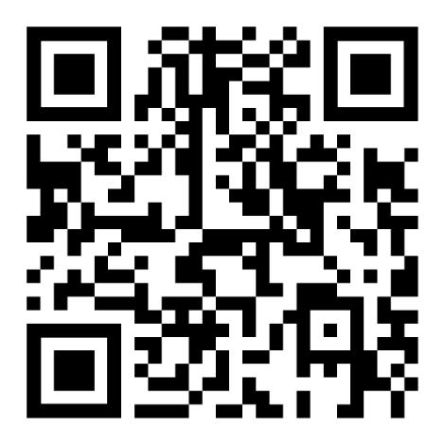

Exhibit 99.2

Form of Scilex Holding Company Opt-In Agreement

The undersigned (“me” or “I”) understands that Scilex Holding Company, a Delaware corporation (the “Company”), declared a dividend (the “Dividend”) of Dream Bowl Meme Coin I tokens (such tokens, the “Dream Bowl Tokens”) to the holders of the following Company securities, in each case as of the close of business on April 30, 2026 (such date, subject to the right of the Company’s board of directors (the “Board”) to change to a later date, the “Record Date”): (i) the Company’s common stock, par value $0.0001 per share (such stock, the “Common Stock” and such record holders, the “Record Common Holders”), (ii) certain warrants to purchase Common Stock that have not been exercised and settled prior to the Record Date (and which have the right to participate in the Dividend pursuant to the terms of their respective warrants, other than, for the avoidance of doubt, any of our publicly traded warrants to purchase Common Stock with an exercise price of $11.50 per share (or $402.50 on a post-reverse stock split basis)) (such record holders, the “Record Warrant Holders”), (iii) certain Tranche B senior secured convertible notes of the Company that have not been converted and settled prior to the Record Date (and which have the right to participate in the Dividend pursuant to the terms of their respective notes) (such record holders, the “Record Note Holders”), and (iv) the Company’s Series A Preferred Stock, par value $0.0001 per share (such stock, the “Series A Preferred Stock” and such record holder, the “Record Preferred Holder” and together with the Record Common Holders, the Record Warrant Holders and the Record Note Holders, the “Record Holders”). The preceding Company securities held by the Record Holders as of the Record Date are collectively referred to herein as the “Securities”.

The Dividend will be (i) made on the basis of five (5) Dream Bowl Tokens for each one (1) share of Common Stock held (or underlying the applicable Securities held) by such Record Holders on the Record Date and (ii) paid beginning on May 26, 2026 (or such other date as determined by the Board, the “Payment Date”), subject to the satisfaction of the Payment Conditions (as defined below) by the applicable Record Holder.

The fair market value per Dream Bowl Token is $0.00000145 as of May 8, 2026 (the “Valuation Date”), based on an independent valuation conducted by a third-party valuation firm at the request of the Company in connection with the Dividend, and such value assumes that the Dream Bowl Tokens are illiquid through June 10, 2026.

By signing below, I hereby acknowledge and agree that:

- Payment of the Dividend is subject to the right of the Board to revoke the Dividend before the Payment Date, and if the Board exercises such right, then I will not receive the Dividend.

- Payment of the Dividend is conditioned on my (a) having (or setting up) a digital wallet with Datavault AI Inc. (“Datavault”) into which Dream Bowl Tokens can be delivered on or after the Payment Date; and (b) electing to receive the Dividend by completing, duly executing, and submitting this Opt-In Agreement (this “Agreement”) to Alliance Advisors, the Company’s information agent (the “Information Agent”), in which, among other things, I will be required to provide a valid and accurate Datavault digital wallet address for the Company to transfer the Dream Bowl Tokens (collectively, the “Payment Conditions”).

- If I do not hold my shares of Common Stock in my name, but rather in an account at a brokerage firm, bank, dealer or other similar organization (any such entity, the “Nominee”), then I further acknowledge and agree that (a) I am a beneficial owner of shares held in “street name” and the Nominee holding my account is considered the stockholder of record, or the Record Common Holder, for purposes of the Dividend, and (b) if the Company is unable to verify the number of shares of Common Stock held by me as set forth below because my shares are held in “street name” through Cede & Co. or other intermediary,

(i) the Company may require that I provide additional documentation to verify such number of shares, including that I may be required to deliver to the Information Agent a copy of my brokerage statement as of the Record Date or other certification regarding my holdings of Common Stock as of the Record Date and any failure to provide such additional documentation to verify the number of shares of Common Stock held by me with such Nominee as set forth below will result in me not receiving my portion of the Dividend until such time as the number of shares that I hold with such Nominee can be verified by the

Information Agent, (ii) I authorize the Company and the Information Agent to contact my Nominee (whose contact details I have provided below) for purposes of verifying my holdings of such stock, and such Nominee is hereby authorized to provide such information to the Company and the Information Agent, (iii) I will, to the fullest extent permitted by law, indemnify and hold the Company and its directors, officers, stockholders, members, partners, employees and agents (each, an “Indemnified Person”) harmless from any and all losses, liabilities, obligations, claims, contingencies, damages, costs and reasonable expenses, including all judgments, amounts paid in settlements, court costs and reasonable attorneys’ fees and costs of investigation that any such Indemnified Person may suffer or incur as a result of or directly relating to (A) any breach of any of the representations, warranties, covenants or agreements made by me in this Agreement or (B) otherwise in connection with the information I have provided herein, including the number of shares of Common Stock set forth below, and (iv) verification of the number of shares of Common Stock that I hold shall be in the sole discretion of the Information Agent.

- The Dividend is an in-kind distribution that may be a dividend (to the extent of the Company’s current and accumulated earnings and profits (“E&P”)). Any amount in excess of E&P would reduce a Record Common Holder’s or Record Preferred Holder’s tax basis in its Common Stock or Series A Preferred Stock, and any amount in excess of that basis should constitute gain. The Company may elect to treat the entire amount as a dividend or may elect to report it in another manner as it decides is appropriate in consultation with the Company’s tax preparers. I agree (and will be required absent disclosure to the Internal Revenue Service (“IRS”) and other tax authorities) to report such amounts in the same manner as the Company.

- The tax treatment of the Dividend with respect to the Record Warrant Holders and the Record Note Holders of the Dream Bowl Token is unclear. Such distribution could be treated as a dividend, or additional interest (in the case of the Record Note Holders), or may be subject to another treatment. The Company will report such amounts in such manner as it decides is appropriate in consultation with its tax preparers. I agree (and will be required absent disclosure to the IRS and other tax authorities) to report such amounts in the same manner as the Company.

- I will comply with my tax reporting obligations with respect to the Dream Bowl Tokens in accordance with the terms of this Agreement.

- I have read the Company’s Current Report on Form 8-K filed with the Securities and Exchange Commission on May 11, 2026 and understand the process to obtain the Dividend.
- Any fees charged by my Nominee in connection with the Dividend will be my sole responsibility.

- Failure to provide a valid Datavault digital wallet address or providing an inaccurate Datavault digital wallet address to the Company will result in me losing my rights to the Dividend.

- Following the Company’s initial deposit of my Dream Bowl Tokens into my Datavault digital wallet, any fees charged to transfer any Dream Bowl Tokens will be my responsibility, including any transaction fees for trading my Dream Bowl Tokens after such coins have been deposited in my digital wallet.

- The value of the Dream Bowl Tokens may change between the Valuation Date and the Payment Date and may also change after the Payment Date; I accept the risk of such changes, and the Company will not be responsible for any decrease in the value of the Dream Bowl Tokens at any time, including if such Dream Bowl Tokens are worthless.

2

- The Dream Bowl Token is a digital collectible intended solely for personal, non-commercial use. The Dream Bowl Token does not in and of itself: (a) represent or confer any equity, voting, dividend, profit-sharing, or ownership rights in the Company or any other entity; (b) provide any right to receive monetary payments, distributions, or appreciation; or (c) create any expectation of profit or reliance on the managerial or entrepreneurial efforts of the Company or others. The Dream Bowl Token is not designed or intended to function as an investment, currency, or financial product, and it is not being offered, sold, or distributed for fundraising or capital-raising purposes. Use of the Dream Bowl Token is limited to entertainment, event-access, and digital-collectible functions. Any transferability features are provided solely to support personal digital item portability and not to facilitate or imply investment or speculative use.

This Agreement documents my irrevocable election (“Election”) to satisfy the Payment Conditions, comply with the terms and conditions as set forth in this Agreement, including with respect to my tax reporting obligations, and receive payment of the Dividend. I acknowledge and agree that by submitting my signature on this Agreement in a “.pdf” format data file or other digital format, such signature shall create a valid and binding obligation on me (or, if signing for an entity, the entity on whose behalf such signature is executed) with the same force and effect as if such “.pdf” or other digital signature page were an original thereof.

I hereby represent that:

- The information below is accurate and complete.

- I have read this Agreement in its entirety and understand the risks (which, in part, are described below under “Risk Factors”) and terms and conditions of this Agreement.

- (A) If an entity, I am duly organized, validly existing, and in good standing under the laws of the jurisdiction of my organization, (B) I have all requisite power and authority or legal capacity to enter into this Agreement and perform my obligations hereunder, and (C) my execution and delivery of this Agreement have been duly authorized by all necessary action, as applicable.

- I have been advised, and have had the opportunity, to consult with my own legal and tax advisors to be able to evaluate my election to receive the Dividend and execute this Agreement, and I have evaluated the legal, tax and other consequences of the Dividend and my execution of this Agreement.

Name or entity name your shares are registered under:

If entity, name and title of authorized signer:

Address:

(address on file with the Nominee(s), the Transfer Agent (as defined below) or the Company)

Phone Number:

Email:

3

Number of shares of Common Stock:¹
Please provide the applicable information:
My shares are already on the books and records of the Transfer Agent | _____ | Yes
 | _____ | No
My shares are held in an account at one or more brokerage firms, banks, dealers or | Name of Nominee:___________________
other similar organizations and each such Nominee’s contact information is as
follows: | Phone No.: _________________________

Email: ____________________________

If more than one Nominee:

Name of Nominee:___________________

Phone No.: _________________________

Email: ____________________________

- Stockholder of Record: Shares Registered in Your Name. If at the close of business on the Record Date, your shares of Common Stock were registered directly in your name with Continental Stock Transfer & Trust Company, the Company’s transfer agent (the “Transfer Agent”), then you are the stockholder of record for such shares and a Record Common Holder and you will be eligible to receive the Dividend, subject to the terms of this Agreement, including the satisfaction of the Payment Conditions. If there is any conflict between the amount of shares of Common Stock stated herein and the records of the Transfer Agent, then the Transfer Agent’s records shall prevail in accordance with the terms and conditions of this Agreement.

Beneficial Owner: Shares Registered in the Name of a Nominee. If at the close of business on the Record Date, your shares of Common Stock were held, not in your name, but rather at a brokerage firm, bank, dealer or other similar organization (i.e., with a Nominee), then you are a beneficial owner of shares held in “street name”, and such Nominee is considered the stockholder of record, or the Record Common Holder, and such Nominee should have distributed to you a letter from the Company informing you that you will be eligible to receive the Dividend, subject to the terms of this Agreement, including the satisfaction of the Payment Conditions and delivery of any additional information necessary to confirm your holdings of Common Stock as described elsewhere in this Agreement. As noted elsewhere in this Agreement, if the Company is unable to verify the number of shares of Common Stock that you hold with such Nominee as set forth in the column to the right, no Dream Bowl Tokens will be distributed to you until such time as your share information can be verified by the Information Agent.

4

Name of Nominee:___________________

Phone No.: _________________________

Email: ____________________________

Number of shares of Series A Preferred Stock:

Number of shares of Common Stock issuable upon exercise of Record Warrants:²

Number of shares of Common Stock issuable upon exercise of Record Notes:²

Datavault Wallet Address:

Confirm Datavault Wallet Address:

(Dream Bowl Token transactions are irreversible; it is advised that you cut and paste your digital wallet address into this field)

***

RISK FACTORS

Prior to making any decision regarding your execution of this Agreement and acceptance of Dream Bowl Tokens, you should carefully consider the following Risk Factors. If any of the events discussed in the Risk Factors occur, the value of the Dream Bowl Tokens you receive could be adversely affected.

The value of the Dream Bowl Tokens may increase or decrease between the Record Date and the Payment Date and/or at any time following the Payment Date. The value of such tokens may also be highly volatile.

The Dividend will be in the form of a digital asset, the Dream Bowl Token. If the value of the Dream Bowl Tokens decreases between the Record Date and the Payment Date, participating holders may receive less value than initially expected by those who elected to receive the Dividend. Additionally, the value of the Dream Bowl Token may decrease after the Payment Date. Once you have made the Election, it is irrevocable. The Company will not be responsible for any decrease in the value of the Dream Bowl Tokens.

- If you are a Record Warrant Holder and/or Record Note Holder, all shares of Common Stock subject to the applicable Securities held in your record name (on the books and records of the Company) on the Record Date will be eligible to receive the Dividend, subject to the terms of this Agreement, including the satisfaction of the Payment Conditions. If there is any conflict between the amount of shares of Common Stock subject to your Securities as stated herein and the records of the Company, then the Company’s records shall prevail.

5

In addition, digital assets, such as the Dream Bowl Token, generally are highly volatile assets and do not pay interest or other returns, and so the ability to generate a return on the Dream Bowl Tokens will depend on whether there is appreciation in the value of digital assets.

The irreversibility of digital asset transactions exposes you to risks of theft, loss and human error, which could negatively impact your rights to the Dividend.

Once a transaction has been verified and recorded in a block that is added to the blockchain, an incorrect transfer of digital assets or a theft of digital assets generally will not be reversible, and you may not be capable of seeking compensation for any such transfer or theft. If you provide the Company with the wrong wallet address (which is a valid address), the owner of such wallet address will receive the benefit of your Dream Bowl Token Dividend, and you will receive nothing. The Company will be unable to revert or otherwise recover the impacted digital assets and will not be responsible for any loss. If you provide the Company with an invalid wallet address and the transfer is rejected by the Datavault network, the Company may, at its option, refuse or reasonably delay payment of the Dividend. You are encouraged to confirm your wallet address prior to submitting your Election.

Dream Bowl Tokens and other digital assets are novel assets and are subject to significant legal, commercial, regulatory and technical uncertainty.

The Dream Bowl Tokens and other digital assets are relatively novel and are subject to significant legal, commercial, regulatory and technical uncertainty, which could adversely impact their price. The application of state and federal securities laws and other laws and regulations to digital assets is unclear in certain respects, and it is possible that regulators in the United States or foreign countries may interpret or apply existing laws and regulations in a manner that adversely affects the price of the Dream Bowl Token. Regulators in the United States or foreign countries may also enact new laws and regulations, or pursue regulatory, legislative, enforcement or judicial actions, that could materially impact the price of the Dream Bowl Tokens or the ability of individuals or institutions to own or transfer Dream Bowl Tokens.

The growth of the digital assets industry in general, and the use and acceptance of the Dream Bowl Token in particular, may also impact the price of the Dream Bowl Tokens and is subject to a high degree of uncertainty. The pace of worldwide growth in the adoption and use of the Dream Bowl Token may depend on, for instance, public familiarity with digital assets, ease of buying, accessing or gaining exposure to the Dream Bowl Token, institutional demand for the Dream Bowl Token as an investment asset, the participation of traditional financial institutions in the digital assets industry, consumer demand for the Dream Bowl Token as a means of payment, and the availability and popularity of alternatives to the Dream Bowl Token. Even if growth in Dream Bowl Token adoption occurs in the near or medium term, there is no assurance that Dream Bowl Token usage will continue to grow over the long term.

Because the Dream Bowl Token has no physical existence beyond the record of transactions on the Dream Bowl Token blockchain, a variety of technical factors related to the Dream Bowl Token blockchain could also impact the price of Dream Bowl Tokens. The liquidity of the Dream Bowl Tokens may also be reduced, and damage to the public perception of the Dream Bowl Token may occur, if financial institutions were to deny or limit banking services to businesses that hold the Dream Bowl Tokens, provide Dream Bowl Token-related services or accept the Dream Bowl Token as payment, which could also decrease the price of the Dream Bowl Tokens.

The liquidity of the Dream Bowl Token may also be impacted to the extent that changes in applicable laws and regulatory requirements negatively impact the ability of exchanges and trading venues to provide services for the Dream Bowl Token.

The lack of legal recourse and insurance for digital assets increases the risk of total loss in the event of theft or destruction.

Digital assets, including the Dream Bowl Tokens, will generally not be insured against theft, loss or destruction. If an event occurs in which you lose your Dream Bowl Tokens, whether due to cyberattacks, fraud or other malicious activities, you may not have any viable legal recourse or ability to recover the lost assets. Unlike funds held in insured banking institutions, digital assets are not protected by the Federal Deposit Insurance Corporation or the Securities Investor Protection Corporation. If your digital assets, including Dream Bowl Tokens, are lost under

6

circumstances that render another party liable, there is no guarantee that the responsible party will have the financial resources to compensate you. As a result, you could face financial losses.

Cryptocurrency holdings are less liquid than cash and cash equivalents and may not be able to serve as a source of liquidity for you to the same extent as cash and cash equivalents.

Historically, the crypto markets have been characterized by significant volatility in price, limited liquidity and trading volumes compared to sovereign currencies markets, relative anonymity, a developing regulatory landscape, potential susceptibility to market abuse and manipulation, compliance and internal control failures at exchanges, and various other risks inherent in its entirely electronic, virtual form and decentralized network. During times of market instability, you may not be able to sell your cryptocurrency at favorable prices or at all.

Further, cryptocurrency, such as the Dream Bowl Token, does not enjoy the same protections as are available to cash or securities deposited with or transacted by institutions subject to regulation by the Federal Deposit Insurance Corporation or the Securities Investor Protection Corporation. You could be unable to sell Dream Bowl Tokens or have to sell Dream Bowl Tokens at a significant loss.

Dream Bowl Tokens do not pay interest or dividends.

Dream Bowl Tokens do not pay interest or other returns, and you may only be able to generate cash from Dream Bowl Tokens if you sell your Dream Bowl Tokens or implement strategies to create income streams or otherwise generate cash by using your Dream Bowl Token holdings. Even if you pursue any such strategies, you may be unable to create income streams or otherwise generate cash from Dream Bowl Tokens, and any such strategies may subject you to additional risks.

If we or our third-party service providers experience a security breach or cyberattack and unauthorized parties obtain access to your Dream Bowl Tokens, or if your private keys are lost or destroyed or other similar circumstances or events occur, you may lose some or all of your Dream Bowl Tokens.

Security breaches and cyberattacks are of particular concern with respect to cryptocurrency, including Dream Bowl Tokens. Blockchain-based cryptocurrencies and the entities that provide services to participants in the cryptocurrency ecosystem have been, and may in the future be, subject to security breaches, cyberattacks, or other malicious activities. A successful security breach or cyberattack could result in a partial or total loss of your cryptocurrency in a manner that may not be covered by insurance or the liability provisions of the custody agreements with the custodians who hold your cryptocurrency.

I understand that there may be legal and tax consequences from the Election, execution of the Opt-In Agreement and receipt of the Dividend. The Company encourages all Record Holders to seek legal and tax advice from qualified legal counsel and a tax professional before deciding to make the Election, execute this Agreement and receive the Dividend.

We encourage any Record Holder that has questions concerning the Election process to contact Alliance Advisors, our Information Agent, at 1-866-206-7441 (or 1-315-658-0069 for international holders) or SCLX@allianceadvisors.com. This Agreement may be executed and submitted to the Information Agent only via www.SCLXdreambowl1coin.com. Any Agreement that is mailed, faxed, or emailed to any representative of the Company or to the Information Agent will not be accepted.

I hereby make my irrevocable Election to accept the Dividend, subject to the foregoing terms and conditions.

Dated: ____________________________________
IF AN ENTITY: | IF AN INDIVIDUAL:
Signature: | Signature:
 | 7

Name: Name:

Title:

Entity:

[signature page to Opt-In Agreement]

8

Exhibit 99.3

Onboarding Documentation - Datavault AI Wallet Creation

Step 1:

Visit https://datavault.one/
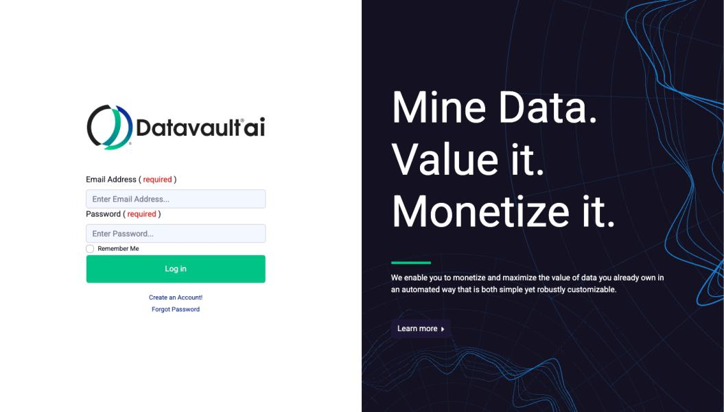

Step 2:

Click Create an Account!
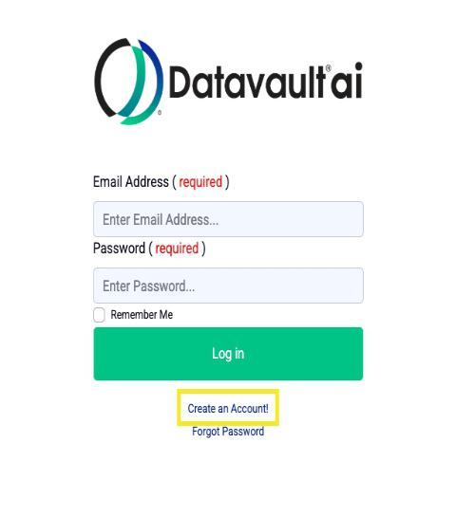

Step 3:

Enter personal email address to create Datavault username.
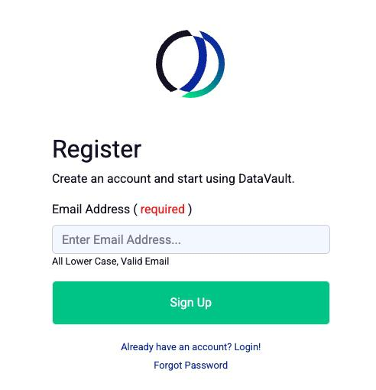

Step 4:

Open personal email to retrieve activation code
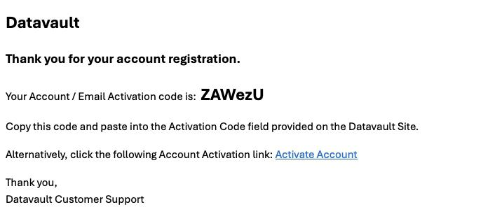

Step 5:

Copy and paste Activation Code or click Activate Account link. Create Password based on password requirements listed.
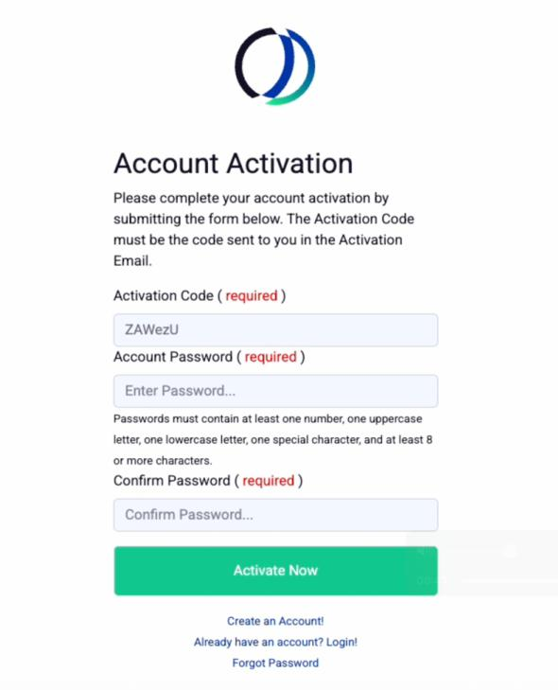

Step 6:

Login with email address and password
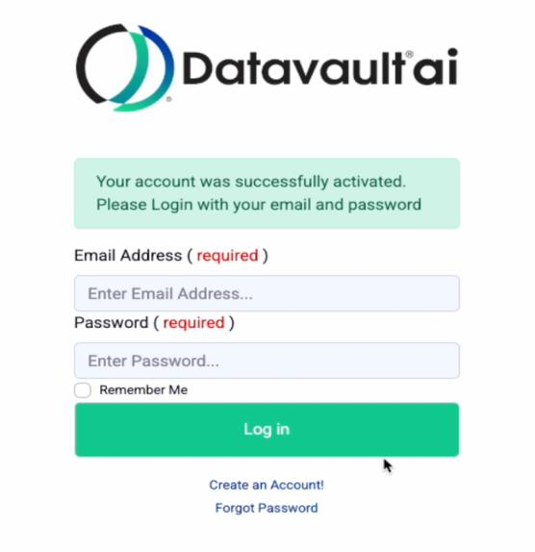

Step 7:

Dream Bowl Meme Coin I tokens will be deposited beginning on the payment date and after all conditions/verifications have been completed.
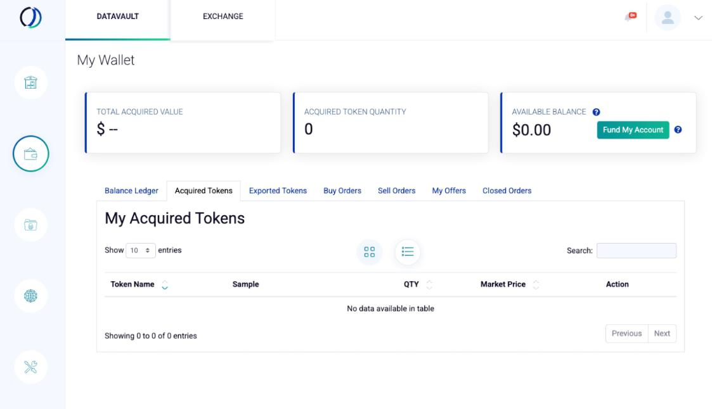

Exhibit 99.4

SCILEX HOLDING COMPANY

FREQUENTLY ASKED QUESTIONS

REGARDING THE DREAM BOWL MEME COIN I DIVIDEND

This FAQ addresses details of the distribution of the Dream Bowl Meme Coin I tokens to certain record holders of common stock and certain other equity securities of Scilex Holding Company (the “Company”), including the record date, payment date, distribution ratio, opt-in and digital wallet requirements.

- What is the distribution of Dream Bowl Meme Coin I tokens to certain holders of Company equity securities?

- On April 20, 2026, the Company announced that its board of directors (the “Board”) declared a dividend (“Dividend”) of five (5) Dream Bowl Meme Coin I tokens (such tokens, the “Dream Bowl Tokens”) for each one (1) share of the Company’s common stock, par value $0.0001 per share (the “Common Stock”), held or deemed to be held by certain Company equityholders for purposes of the Dividend pursuant to certain contractual rights of the holders of the following equity securities of the Company, in each case as of the close of business on the Record Date (as defined below):

  - Common Stock (“Record Common Holders”),

- certain warrants to purchase Common Stock that have not been exercised and settled prior to the Record Date (and which have the right to participate in the Dividend pursuant to the terms of their respective warrants, other than, for the avoidance of doubt, any of our publicly traded warrants to purchase Common Stock with an exercise price of $11.50 per share (or $402.50 on a post-reverse stock split basis)) (such warrants, the “Record Warrants” and such record holders, the “Record Warrant Holders”),

- certain Tranche B senior secured convertible notes of the Company that have not been converted and settled prior to the Record Date (and which have the right to participate in the Dividend pursuant to the terms of their respective notes) (such notes, the “Record Notes” and such record holders, the “Record Note Holders”), and

- the Company’s Series A Preferred Stock, par value $0.0001 per share (such stock, the “Series A Preferred Stock” and such record holder, the “Record Preferred Holder” and together with the Record Common Holders, the Record Warrant Holders and the Record Note Holders, the “Record Holders”).

The preceding Company securities held by the Record Holders as of the Record Date are collectively referred to herein as the “Securities”.

- What is the Dream Bowl Token?

- The Dream Bowl Token is a digital collectible intended solely for personal, non-commercial use. The Dream Bowl Token does not in and of itself: (a) represent or confer any equity, voting, dividend, profit-sharing, or ownership rights in the Company or any other entity; (b) provide any right to receive monetary payments, distributions, or appreciation; or (c) create any expectation of profit or reliance on the managerial or entrepreneurial efforts of the Company or others. The Dream Bowl Token is not designed or intended to function as an investment, currency, or financial product, and it is not being offered, sold, or distributed for fundraising or capital-raising purposes. Use of the Dream Bowl Token is limited to entertainment, event-access, and digital-collectible functions. Any transferability features are provided solely to support personal digital item portability and not to facilitate or imply investment or speculative use.

- What is the Record Date for the Dividend to the Record Holders?

- The record date for determining the Record Holders who are entitled to receive Dream Bowl Tokens was April 30, 2026 (the “Record Date”), subject to the right of the Board to change the Record Date to a later date.

- What is the Payment Date for the Dream Bowl Tokens to be Distributed to Record Holders?

- The Dividend will be paid beginning on May 26, 2026 (“Payment Date”), subject to the right of the Board to change the Payment Date to a later date or to revoke the Dividend entirely prior to the Payment Date.

- Can the Board revoke the Dividend to Record Holders?

- Yes, the Board has the right to revoke the Dividend prior to the Payment Date.

- How will I know if the Board changes the Record Date or Payment Date or otherwise revokes the Dividend to Record Holders?

- If the Board changes the Record Date or Payment Date or otherwise revokes the Dividend to Record Holders prior to the Payment Date, the Company will file a Current Report on Form 8-K with the Securities and Exchange Commission to announce such changes or revocation.

- Will I receive Dream Bowl Tokens if I am a Record Holder?

- If you are a Record Holder, meaning you held Securities as of the close of business on the Record Date, you are entitled to receive Dream Bowl Tokens, subject to your having:

  - a digital wallet with Datavault AI Inc. (“Datavault”) into which Dream Bowl Tokens can be delivered on or after the Payment Date (please note that the Record Holder’s opt-in email address must match the email address associated with their Datavault wallet); and

- elected to receive the Dividend by completing, duly executing, and submitting an Opt-In Agreement to Alliance Advisors, the Company’s Information Agent (the “Information Agent”), in which, among other things, you will be required to provide a valid and
accurate Datavault digital wallet address for the Company to transfer the Dream Bowl Tokens.

If you do not already have a digital wallet with Datavault, instructions on how to set up a digital wallet with Datavault can be found at www.SCLXdreambowl1coin.com (the “Dividend Website”).

You may initiate your election to receive your portion of the Dividend by completing, executing and submitting the Opt-In Agreement, which can be accessed at the Dividend Website. Once you have printed and executed the Opt-In Agreement, you will need to upload the completed and executed agreement via a secure link on the Dividend Website under the field “Upload Your Opt-In Agreement”.

- How many Dream Bowl Tokens will I receive if I am a Record Holder?

- If you are a Record Common Holder, then you will receive five (5) Dream Bowl Tokens for each one (1) share of Common Stock held by you as of the close of business on the Record Date.

If you are a Record Warrant Holder, Record Note Holder or Record Preferred Holder, you will receive five (5) Dream Bowl Tokens for each one

  - share of Common Stock underlying the applicable Securities held by you as of the close of business on the Record Date, as determined pursuant to the terms of the applicable Security you hold.

- How do I know if I am a Record Common Holder?

2

- Stockholder of Record: Shares Registered in Your Name

If, at the close of business on April 30, 2026, your shares of Common Stock were registered directly in your name with the Company’s transfer agent, Continental Stock Transfer & Trust Company (“CST”), then you are the stockholder of record for these shares and a Record Common Holder.

Beneficial Owner: Shares Registered in the Name of a Broker, Bank or Other Agent

If, at the close of business on April 30, 2026, your shares of Common Stock were held, not in your name, but rather in an account at a brokerage firm, bank, dealer or other similar organization, then you are the beneficial owner of shares held in “street name”, and the organization holding your account is considered the stockholder of record, or the Record Common Holder, for purposes of the Dividend.

- What information was distributed to the Record Common Holders in connection with the Dividend?

- Stockholder of Record: Shares Registered in Your Name

If, at the close of business on April 30, 2026, your shares of Common Stock were registered directly in your name with CST, then the Information Agent, on the Company’s behalf, mailed a letter to your address on record with CST describing the Dividend and informing you about the process of electing to receive your portion of the Dividend by having or setting up your digital wallet and uploading your completed, executed Opt-In Agreement by navigating to the Dividend Website.

On the Dividend Website, you will find, among other information, the following (collectively, with this letter, the “Dividend Materials”):

(i) These FAQs regarding the Dividend.

(ii) Instructions for setting up a digital wallet with Datavault (if you don’t already have a digital wallet with Datavault).

- A form of Opt-In Agreement to be completed and executed by you and submitted to the Information Agent by uploading the completed and executed agreement via a secure link on the Dividend Website under the field “Upload Your Opt-In Agreement”.

Beneficial Owner: Shares Registered in the Name of a Broker, Bank or Other Agent

If, at the close of business on April 30, 2026, your shares of Common Stock were held, not in your name, but rather in an account at a brokerage firm, bank, dealer or other similar organization, then you are the beneficial owner of shares held in “street name”, and the organization holding your account is considered the stockholder of record, or the Record Common Holder, for purposes of the Dividend.

As a Record Common Holder, your brokerage firm, bank, dealer or other similar organization should have received the cover letter from the Company and will be responsible for distributing such cover letter to you.

Please visit the Dividend Website at www.SCLXdreambowl1coin.com or contact the Information Agent by phone or email at:

Alliance Advisors

Telephone Number: 1-866-206-7441 (or 1-315-658-0069 for international holders)

Email Address: SCLX@allianceadvisors.com

to coordinate as necessary with your brokerage firm, bank, dealer or other similar organization.

- How do I know if I am a Record Warrant Holder, Record Note Holder or Record Preferred Holder

- If, at the close of business on April 30, 2026, you held Record Warrants, Record Notes and/or Series A Preferred Stock, such securities were registered directly in your name with the Company and you are the holder of record for such securities and therefore a Record Warrant Holder, Record Note Holder and/or Record Preferred Holder, as applicable, you are entitled to participate in the Dividend.

3

Record Warrants

Based on the books and records of the Company, the following warrants to purchase Common Stock have the right to participate in the Dividend pursuant to their respective terms:

- Common Stock Purchase Warrants, issued March 5, 2024; (ii) Common Stock Purchase Warrants, issued April 25, 2024; (iii) Common Stock Purchase Warrant, issued June 18, 2024;

(iv) Common Stock Purchase Warrants, issued December 13, 2024;

(v) Warrants to Purchase Common Stock, issued October 8, 2024; (vi) Warrants to Purchase Common Stock, issued September 30, 2025; (vii)Common Stock Purchase Warrants, issued November 25, 2025; and (viii)Warrants to Purchase Common Stock, issued February 19, 2026.

Record Notes

Based on the books and records of the Company, certain Tranche B senior secured convertible notes of the Company are issued and outstanding as of the Record Date, have not been converted and settled and the holders thereof are entitled to participate in the Dividend pursuant to the terms of their respective notes.

Series A Preferred Stock

Based on the books and records of the Company, 29,057,097 shares of Series A Preferred Stock are issued and outstanding as of the Record Date, and are entitled to participate in the Dividend on a deemed as-converted to Common Stock basis pursuant to the terms of the Certificate of Designations of the Company for such preferred stock. The Series A Preferred Stock is currently deemed to be convertible into an aggregate of 848,106 shares of Common Stock under the terms of the Certificate of Designations of the Company for such preferred stock.

- What information was distributed to the Record Warrant Holders, Record Note Holders and Record Preferred Holder in connection with the Dividend?

- If, at the close of business on April 30, 2026, you held Record Warrants, Record Notes and/or Series A Preferred Stock, then such securities were registered directly in your name with the Company (and not with the Company’s transfer agent), and the Information Agent, on the Company’s behalf, mailed a letter to your address on record with the Company describing the Dividend and informing you about the process of electing to receive your portion of the Dividend by setting up your digital wallet with Datavault (if you don’t already have one) and uploading your completed, executed Opt-In Agreement by navigating to the Dividend Website at www.SCLXdreambowl1coin.com.

- What if I hold Record Warrants that have not been exercised in full or are otherwise subject to limitations on participating in the Dividend, in each case, as of the Record Date and/or Payment Date?

- The portion of the Dividend with respect to the unexercised portion of Record Warrants that have not been exercised in full shall be distributed on the same basis as the Dividend is made to Record Common Holders.

- What if I am a holder of Securities and did not receive a letter from the Company describing the Dividend and informing me about the process of electing to receive my portion of the Dividend or I have questions about how to receive the Dream Bowl Tokens?

- Stockholder of Record: Shares Registered in Your Name

To obtain a copy of the letter from the Company, or if you have questions about such letter, the Dividend Website, and/or how to receive the Dream Bowl Tokens or, subject to having completed and executed the Opt-In Agreement and having a digital wallet with Datavault, to check on the status of the deposit of your

4

Dream Bowl Tokens in your digital wallet from and after the Payment Date, please visit the Dividend Website at www.SCLXdreambowl1coin.com or contact the Information Agent by phone or email at:

Alliance Advisors

Telephone Number: 1-866-206-7441 (or 1-315-658-0069 for international holders)

Email Address: SCLX@allianceadvisors.com

Beneficial Owner: Shares Registered in the Name of a Broker, Bank or Other Agent

If you hold your shares in “street name” through a brokerage firm, bank, dealer or other similar organization, that organization received the cover letter with respect to all Common Stock held by its customers; please visit the Dividend Website at www.SCLXdreambowl1coin.com or contact the Information Agent by phone or email at:

Alliance Advisors

Telephone Number: 1-866-206-7441 (or 1-315-658-0069 for international holders)

Email Address: SCLX@allianceadvisors.com

to coordinate as necessary with your brokerage firm, bank, dealer or other similar organization.

Record Warrant Holder, Record Note Holder and Record Preferred Holder

To obtain a copy of the letter from the Company, or if you have questions about such letter, the Dividend Website, and/or how to receive the Dream Bowl Tokens or, subject to having completed and executed the Opt-In Agreement and having a digital wallet with Datavault, to check on the status of the deposit of your Dream Bowl Tokens in your digital wallet from and after the Payment Date, please visit the Dividend Website at www.SCLXdreambowl1coin.com or contact the Information Agent by phone or email at:

Alliance Advisors

Telephone Number: 1-866-206-7441 (or 1-315-658-0069 for international holders)

Email Address: SCLX@allianceadvisors.com

- Can I obtain, complete and submit the relevant Dividend Materials online?

- Yes. In the cover letter that was mailed by the Company, there is a QR Code that you may scan to obtain access to the Dividend Website hosted by the Information Agent, where you can obtain a copy of the Dividend Materials and instructions on how to complete and submit your Opt-In Agreement and, if you don’t already have one, set up a digital wallet with Datavault. Please note that your opt-in email address must match the email address associated with your Datavault wallet.

You must initiate the process of electing to receive your portion of the Dividend by setting up your digital wallet with Datavault (unless you already have one) and completing the Opt-In Agreement by navigating to the Dividend Website at www.SCLXdreambowl1coin.com. On the Dividend Website, you can view and download the Dividend Materials, set up a digital wallet with Datavault, and print, complete and submit your Opt-In Agreement.

- Why am I being asked to have a digital wallet with Datavault to receive the Dream Bowl Tokens?

- The Dream Bowl Tokens are a digital asset and can only be held in a digital wallet. It is a condition to the receipt of the Dream Bowl Tokens in the Dividend that you have a digital wallet hosted by Datavault.

If you don’t already have a digital wallet with Datavault, instructions for opening a digital wallet with Datavault can be found on the Dividend Website at www.SCLXdreambowl1coin.com.

- If I have an existing digital wallet with Datavault, will I be required to create a new digital wallet to participate in the Dividend?

5

- No.

- Why am I being asked to execute and deliver an Opt-In Agreement?

- Execution of the Opt-In Agreement is also a condition to the receipt of the Dream Bowl Tokens.

By executing an Opt-In Agreement, you are, among other things, agreeing to the payment conditions set forth therein, and acknowledging that you understand the process for receiving the Dream Bowl Tokens, that the Board can change the Record Date, Payment Date or revoke the Dividend, and that the Dream Bowl Tokens may not have or maintain any value.

If you hold your shares in “street name” through a brokerage firm, bank, dealer or other similar organization, then, in connection with your execution and delivery of the Opt-In Agreement, (a) the Company may require additional documentation to verify the number of shares of Common Stock you hold, including the delivery of a copy of your brokerage statement as of the Record Date (or a full monthly statement for April 2026) or other certification regarding your holdings of Common Stock as of the Record Date, (b) you will need to authorize the Company and the Information Agent to contact your brokerage firm, bank, dealer or other similar organization for purposes of verifying your holdings, and

(c) you will be required to indemnify the Company and its directors, officers, stockholders, members, partners, employees and agents to the fullest extent permitted by law with respect to certain losses arising in connection with your participation in the Dividend, including any inaccuracy in the number of shares of Common Stock set forth in your Opt-In Agreement, as more fully described therein. Verification of the number of shares of Common Stock that you hold shall be in the sole discretion of the Information Agent based on the certifications and/or other records and information presented by the applicable Record Holder.

The Company urges you to read carefully the Opt-In Agreement prior to making any decision to accept the Dream Bowl Tokens.

- If I hold my shares of Common Stock in “street name” through more than one brokerage firm, bank, dealer or other similar organization, can I deliver one Opt-In Agreement for all of my shares?

- If you hold your shares of Common Stock in “street name” through more than one brokerage firm, bank, dealer or other similar organization, then you will need to identify in the Opt-In Agreement the aggregate number of shares of Common Stock held at each separate brokerage firm, bank, dealer or other similar organization.

- If I delivered opt-in agreements or other documentation to the Information Agent in connection with prior dividends or distributions declared by the Company, am I required to execute and deliver the Opt-In Agreement with respect to this Dividend?

- Yes.

- If I hold my shares of Common Stock in “street name” and the Information Agent is unable to verify the number of shares that I hold, will I be able to receive my portion of the Dividend?

- If you hold your shares of Common Stock in “street name” with a brokerage firm, bank, dealer or other similar organization and the Information Agent is unable to verify the number of shares that you hold with such brokerage firm, bank, dealer or other similar organization, including if you fail to provide additional documentation to verify the number of shares of Common Stock that you hold in street name, then you will not receive your portion of the Dividend until such time as the number of shares that you hold with such brokerage firm, bank, dealer or other similar organization can be verified by the Information Agent.

6

- The Opt-In Agreement requires that I provide personal information to the Company and the Information Agent. Will that personal information be shared with third parties by the Company or the Information Agent?

- Neither the Company nor the Information Agent will share Record Holder information with third parties.

- What is the value of the Dream Bowl Tokens?

- The fair market value per Dream Bowl Token is $0.00000145, as of May 8, 2026, based on an independent valuation conducted by an independent third-party valuation firm at the request of the Company in connection with the Dividend, and such value assumes that the Dream Bowl Tokens are illiquid through June 10, 2026. See the Risk Factors that form a part of the Opt-In Agreement.

- Will there be a trading market for the Dream Bowl Tokens?

- Yes, the Company intends to list the Dream Bowl Tokens on the Biconomy exchange, a global centralized cryptocurrency exchange (“Biconomy”), at biconomy.com, at a later date. The Company will notify holders of Dream Bowl Tokens via email when they can commence trading the Dream Bowl Tokens on Biconomy. Holders of Dream Bowl Tokens may also be able to export the Dream Bowl Tokens to other digital wallets.

- Will there be fees associated with opening a digital wallet with Datavault?

- No, there will not be fees associated with opening a digital wallet with Datavault.

- Will there be fees associated with transfers of Dream Bowl Tokens or trades made on Biconomy after the initial deposit of Dream Bowl Tokens into my digital wallet?

- The Company will notify holders of Dream Bowl Tokens when they can commence trading the Dream Bowl Tokens on Biconomy.

Trades of Dream Bowl Tokens made on Biconomy will incur ordinary course trading fees that are based on transaction value and embedded within the terms of the applicable smart contract. Dream Bowl Tokens that are exported to and traded on other trading platforms or digital exchanges may be subject to additional fees not imposed by Datavault.

- What are the tax consequences to Record Holders of accepting the Dream Bowl Tokens?

- Record Common Holders and Record Preferred Holder

The distribution of Dream Bowl Tokens is an in-kind distribution that may be a dividend (to the extent of the Company’s current and accumulated earnings and profits (“E&P”)). With respect to Dream Bowl Tokens issued to a Record Common Holder or Record Preferred Holder, any amount in excess of E&P would reduce a Record Common Holder or Record Preferred Holder’s tax basis in its Common Stock or Series A Preferred Stock underlying the dividend and any amount in excess of that basis should constitute gain. The Company may elect to treat the entire amount as a dividend or may elect to report it in another manner as it decides is appropriate in consultation with the Company’s tax preparers. In executing and delivering to the Company the Opt-In Agreement, you agree (and will be required absent disclosure to the Internal Revenue Service (the “IRS”) and other tax authorities) to report such amounts in the same manner as the Company.

The Company intends to notify such record holders of the manner in which it will report such amounts to the IRS by push notifications to digital wallets.

Record Warrant Holders and the Record Note Holders

The tax treatment of the dividend with respect to the Record Warrant Holders and the Record Note Holders of the Dream Bowl Token is unclear. Such distribution could be treated as a dividend, or may be subject to

7

another treatment. The Company will report such amounts in such manner as it decides is appropriate in consultation with the Company’s tax preparers. In executing and delivering to the Company the Opt-In Agreement, you agree (and will be required absent disclosure to the IRS and other tax authorities) to report such amounts in the same manner as the Company.

The Company intends to notify such record holders of the manner in which it will report such amounts to the IRS by push notifications to digital wallets.

- Will I receive any warrants to purchase shares of common stock of Datavault with the Dividend of the Dream Bowl Tokens?

- No. There are no warrants to purchase shares of common stock of Datavault associated with the Dividend of the Dream Bowl Tokens by the Company and no warrants will be issued or delivered to you when you receive the Dream Bowl Token(s). For the avoidance of doubt, the Dream Bowl Tokens referred to herein are Dream Bowl Meme Coin I tokens that were distributed by Datavault to its stockholders, including the Company, on or after December 24, 2025 and such tokens do not have any associated rights for warrants to purchase shares of common stock of Datavault.

- I share an address with another Company stockholder, and we received only one paper copy of the letter from the Company. How may I obtain an additional copy of the letter from the Company?

- The Company has adopted a procedure called “householding”. Under this procedure, the Company delivers a single copy of the letter from the Company to multiple stockholders and other equityholders who share the same address, unless it has received contrary instructions from one or more of such stockholders or other equityholders. This procedure reduces our printing costs, mailing costs and fees. Stockholders and other equityholders who participate in householding will continue to be able to access and receive separate letters from the Company. Upon written or oral request, the Company (through the Information Agent) will deliver promptly a separate copy of the letter from the Company to any stockholder or other equityholder at a shared address to which the Company delivered a single copy of any of these materials. To receive a separate copy, or, if a stockholder or other equityholder is receiving multiple copies, to request that we only send a single copy of the letter from the Company, such stockholder or other equityholder may contact the Information Agent at:

Alliance Advisors

Telephone Number: 1-866-206-7441 (or 1-315-658-0069 for international holders)

Email Address: SCLX@allianceadvisors.com

We encourage stockholders to contact the Information Agent by telephone or e-mail instead of physical mail to help ensure timely receipt of any request a copy of the letter from the Company.

- I share an address with another Company stockholder. Am I required to have my own digital wallet with Datavault?

- Yes, each Record Holder is required to have their own digital wallet with Datavault in order to receive the Dividend.

- I am a non-U.S. Record Holder. Am I eligible to participate in the Dividend?

- Yes, non-U.S. Record Holders are eligible to participate in the Dividend on the same terms and conditions as U.S. Record Holders, including as set forth in the Opt-In Agreement and this FAQ.

- Should I seek advice from legal and/or tax advisors before I elect to receive the Dividend?

8

- There may be legal and tax consequences from your election to participate in the Dividend, execution of the Opt-In Agreement and receipt of the Dividend.

The Company encourages all Record Holders to seek legal and tax advice from qualified legal counsel and a tax professional before deciding to elect to participate in the Dividend, execute the Opt-In Agreement and receive the Dividend.

- Is there a deadline to execute and deliver the Opt-In Agreement?

- No. The Company encourages you to execute and deliver the Opt-In Agreement on or prior to the Payment Date. A Record Holder’s execution and delivery of the Opt-In Agreement after the Payment Date may result in delays in the payment of the Dividend to such Record Holder.

9

